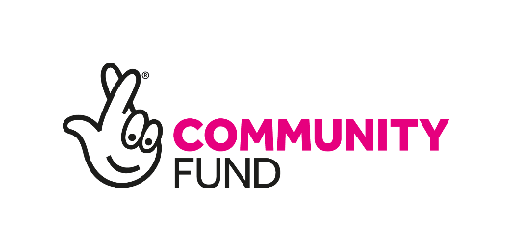
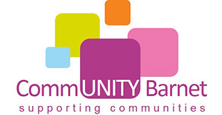
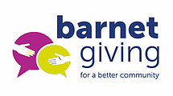
CommUNITY Barnet Giving Covid-19 Emergency Fund
APPLICATION FORM

1. TELL US ABOUT YOUR ORGANISATION

Organisation Details
Please provide your organisation details and the contact details of someone we can speak to, if we have any queries about your application. They should know about the project and be able to speak to us during office hours.

Full name of organisation (the name that appears on your bank account):

Are you part of a larger organisation? Yes / No

Address of organisation:

Postcode:

Telephone number:

Email address:

Name of main contact:

Position of main contact:

Status of organisation (please tick below) If you are a charity and a company, please tick both boxes. | Please insert your registration number
Charitable Incorporated Organisation
Company limited by guarantee that is also a registered charity OR has a not for profit/asset lock clause(s) in their Articles of Association
Charitable Trust
Community Interest Company Limited by Guarantee with a not for profit/asset lock clause(s) in their Articles of Association
Company Interest Company Limited by Shares with a not for profit/asset lock clause(s) in their Articles of Association
Cooperative societies with a not-for-profit/asset lock clause(s) in their Society Rules
Community Benefit Society
Constituted Community Group established for more than 12 months

Staff and Volunteers. Please tell us the number of staff and volunteers that are in your organisation.
Full time staff
Part time staff
Volunteers

Please provide a brief description of your organisation.
What are its aims and the main activities?
(200 words maximum)

2. TELL US ABOUT YOUR PROJECT

Please tick the priority area you are applying for
Equality, social justice and community cohesion
Supporting physical and mental health and wellbeing
Tackling poverty and the impact of poverty

Is this project for
New work
Existing work
Both

Start and end date for your project
Projects must start by May 2021 and finish by December 2021.
Month it will start
Month it will finish

Project Details. (400 words maximum)
- What you will do (your activities)
- Who are the people or community that need help?
- How often will the activities will take place (daily, weekly or monthly etc)?
- Which staff or volunteers will be involved?

Please tell us the number of beneficiaries for your project.
We will also fund projects that have low numbers and where people have challenges and the project will really help them.
Number of individual people/beneficiaries
Tell us more about the people this project will help. (200 words maximum)
What problems do they face? How have they been affected by Covid? How long has this been happening? What is needed to help them? What difference and changes will the project make?
Tell us how your project will be open to and include people. (150 words maximum)
Is your project for people of a particular community, for example, Black or Asian people, young or older people, disabled people or children or older people?
How will you make sure your reach people and are welcoming?

Tell us in which postcode area, ward or neighbourhood your project will take place.

Safeguarding
If you are working with children and young people under 18 years of age or vulnerable adults, tell us what you do to make sure they are safe. For example, do staff/volunteers have DBS checks, do they have training and guidance on safeguarding? (Maximum 150 words)
Do you have a Safeguarding policy?
Do relevant staff and volunteers have DBS
checks?

Do relevant staff and volunteers have safeguarding training?

Please add any other relevant information here.

3. BUDGET
EXPENDITURE

Type of costs | Amount requested (£) |  | Details  Please provide any details here of how you worked out the costs
Staff salaries

Volunteer expenses
(lunch, travel)

Equipment

Activities (publicity, refreshments etc)

Premises costs (if an external venue is being used)

Overheads
(rent, telephone calls, lighting)
Other

Total Expenditure

INCOME Please include any income from other sources (if applicable)
Other funders
Your organisation
Grant amount requested
Total Income

If we fund your project, we will make the grant payment by BACS. Please enter the details of your bank or building society below.

Name of bank/building society
Name of account (this must be an account for your organisation)
Sort code
Account number

Policies Do you have the following in place? If no, CommUNITY Barnet can help you. We may ask you to send these if awarded a grant.
Safeguarding Policy
Equality and Diversity Policy
Data Protection (GDPR) policy

Please upload the following documents | Please click to confirm
Signed and dated constitution
Audited account, Independently Examination Accounts or Income and Expenditure Accounts for the last 12 months

SECTION 6: TERMS AND CONDITIONS AND DECLARATION

If you are awarded a grant, you will need to comply with the National Lottery Community Fund’s terms and conditions. You will also be asked to provide a short summary reports to tell us how your project is progressing.

Please provide scanned signatures below of your Chair and Committee Member.

Organisation Chair
Name (please print)
Signature
Date

Committee member
Name (please print)
Signature
Date

Please submit your application form by Monday 1st March 8am.

We suggest you keep a copy of your completed form for your own records.

